Here is a simple, plain-English summary of what your code does, how it works behind the scenes, and what your output actually means.
1. What Is This Code Trying to Solve?
Imagine a cell tower talking to a smartphone.
- If the smartphone is close, the signal is strong, so the tower can send data very fast using a complex "language" (16-QAM modulation) without making mistakes.
- If the smartphone moves farther away, the signal gets weak. If the tower keeps using that fast language, the words get corrupted (high Bit Error Rate). The tower must either speak louder (turn up power) or switch to a simpler, safer language (BPSK modulation), even if it means sending data a bit slower.
Instead of human engineers writing strict rules for every situation, we trained an AI Brain (Reinforcement Learning) to figure out the perfect balance on its own: Transmit as much data as possible, use as little power as possible, and never let the signal become corrupt.
2. The Main Parts of the Code
Part A: The Virtual Environment (WirelessEnv)
This acts as a "physics simulator" inside your computer:
- The State: At every step, the simulator checks 3 things: how far the user is, how strong the signal path is, and the current Signal-to-Noise Ratio (SNR).
- The Actions (21 Choices): The AI can choose any combination of 7 Power Levels (from $-10\text{ dBm}$ up to $+20\text{ dBm}$) and 3 Speeds/Modulations (BPSK = slow & safe, QPSK = medium, 16-QAM = super fast).
- The Score / Reward:
  - If the AI picks a speed that causes data corruption (Bit Error Rate $>0.1\%$), it gets a harsh penalty ($-10$ points).
  - If the transmission is clean, it gets positive points based on the data speed ($+1$, $+2$, or $+4$ points), minus a tiny penalty for wasting battery power.
Part B: The AI Brain (DQNAgent & QNetwork)
- Replay Memory: The AI saves past experiences into a "memory bank" so it can learn from its past mistakes and successes.
- Epsilon ($ϵ$) / Exploration: At first ($ϵ=1.0$), the AI makes completely random choices to explore what happens. Over time ($ϵ→0.05$), it stops guessing and starts picking the best action it learned.
- Neural Network: The AI uses a simple 2-layer neural network to calculate which of the 21 choices gives the highest future score for the user's current distance and signal.
Part C: The Comparison Rules (Baselines)
To see if the AI is actually smart, we compare it against basic strategies:
- Random: Guessing blindly.
- Fixed heuristic: Always blasting maximum power ($20\text{ dBm}$) at medium speed (QPSK).
- Greedy Rule: A fixed rulebook that automatically picks high speed when close, medium when mid-range, and safe/slow when far away.
3. What Your Output Means
Plaintext
=== TRAINING START ===
Episode 50/1000 | Avg Total Reward: -127.82 | Epsilon: 0.61
Episode 250/1000 | Avg Total Reward: 62.86 | Epsilon: 0.08
Episode 1000/1000 | Avg Total Reward: 64.51 | Epsilon: 0.05
- Beginning (Episodes 1–100): The score is negative ($-127$). The AI is guessing randomly, trying high speeds at low power, corrupting data, and getting penalized.
- Middle (Episodes 150–250): The score jumps into positive numbers ($+62$). The AI figured out the secret: never pick a speed that corrupts the data!
- End (Episodes 300–1000): The score stays consistently high ($+60$ to $+80$). The AI has fully mastered the environment.
Plaintext
=== EVALUATION RUN: DQN AGENT vs BASELINES ===
User Initial Distance: 222.0 meters

Step 1–4: DQN Choice: [20 dBm, 16-QAM] -> SNR: ~32 dB, BER: 0.0000, Reward: 3.80
- At $222\text{ meters}$, the AI saw the signal was clean enough for $20\text{ dBm}$ power.
- It confidently picked 16-QAM (the fastest language = $4\text{ Mbps}$).
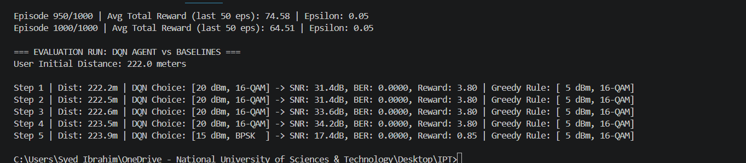
- Result: $0.0000$ error rate (perfect transmission) and a near-maximum reward score of $3.80$ per step!

